**iConsultancy - Social Media Strategy**

Client: Justin K. Zielke, representing the iConsultancy

Aakash Sathish, Gurlal Dhaliwal, Kirk Nii Laryea, Nicolette Hood, & Sarah Peng

May 8, 2025

**Executive Summary**

This project focused on developing a professional and sustainable social media strategy for iConsultancy, a program within the University of Maryland’s College of Information Studies. The goal was to create a structured and easy-to-maintain system to help promote the program’s work with students and client organizations. To meet this goal, our team created a two-month content calendar based on best posting practices, developed reusable post templates, and provided recommendations on the branding and tone. The strategy reflects client feedback, research on effective social media practices, and inspiration from how other universities promote similar programs on social media. The final deliverables include a fully developed posting plan, visual content templates, and clear guidance for implementation. This allows iConsultancy to establish a consistent online presence that staff can manage.

**Introduction**

**About iConsultancy** iConsultancy connects values-driven organizations with UMD iSchool students who apply their academic skills to solve real-world problems. The program operates like a consulting agency, offering creative solutions while fostering student learning and long-term partner relationships with clients. The iConsultancy wants to build strategic, long-term partnerships with different organizations that share the University of Maryland’s values.

**Project Motivation** As iConsultancy expands, so does the need to build its digital footprint. This strategy aims to increase visibility, promote success stories, and attract new client organizations while engaging current students and stakeholders. They want to show off the successful projects and highlight the current clients to spread awareness of the University of Maryland’s iConsultancy and iSchool. Highlighting the program and sharing compelling stories of the partnerships made can optimize existing channels and enhance content quality.

**Project Goals**

This project aimed to help iConsultancy build a consistent and professional social media presence that reflects the program’s mission and values. The goal was to create a structured posting plan that showcases client collaborations, supports student engagement, and attracts prospective clients. The strategy needed to be easy to maintain over time, allowing the program to continue highlighting its impact and expanding its digital reach.

**Scope of Work** This project’s scope encompassed designing and developing a professional social media strategy tailored to the University of Maryland’s iConsultancy program. The goal was to enhance iConsultancy’s digital presence by creating a structured and strategic approach to content planning, audience engagement, and platform optimization.

Our team reviewed background materials and available user research to gain insight into key target audiences' behaviors, preferences, and engagement habits. These included prospective clients, undergraduate and graduate students, alums, and campus partners. We also identified the types of content most likely to resonate with each group, drawing on best practices in social media engagement and branding.

Building on this analysis, we developed a platform-specific strategy leveraging the client’s event calendar and audience personas. The strategic framework included:

* Content recommendations customized by audience segment and platform
* Guidelines for timing and frequency of posts to maximize visibility and engagement
* Suggested best practices to support audience growth and maintain consistent brand messaging across LinkedIn, Instagram, and Facebook.

The strategy also incorporates metrics tracking and performance evaluation guidelines to support ongoing impact. We identified key performance indicators (KPIs), such as follower growth, post engagement, and click-through rates, to enable the client to monitor the success of their outreach efforts and make informed adjustments over time.

**Methodology**

**Process**

Our team followed an agile approach structured around four key phases:

**Sprint 1 – Discovery & Research**

In our first sprint, we focused on understanding what we were working with and what our goal was with our social media posts. In our first few meetings with our primary contact, Justin Zielke, we better understood what we needed the social media to accomplish: attracting new clients, showcasing client collaboration, and supporting student engagement. Using this new information as well as some resources given to us, like a Frequently Asked Questions document, as well as an up-to-date projects and clients spreadsheet, we were able to mock up ideas of posts that we could pass on to Justin in our next meeting to see if they were up to his standards and conveyed what he wanted.

**Sprint 2 – Strategy Development**

During sprint 2, we prioritized researching social media posts and how to gain retention and making our previous ideas into templates for the iConsultancy team to create multiple posts with little modifications easily. During our research, we found the optimal times to post to gain the most engagement for our social media platforms and the official color scheme for UMD that the iConsultancy would also follow to implement in our templates. We also researched other pages and social media strategies to gain inspiration for our strategy development.

**Sprint 3 – Design and Testing**

Sprint 3 focused more on fine-tuning what we already had to the client’s exact needs and developing a scheduled calendar based on the research we had done in the previous sprint. We coordinated with the iSchool communications team and our client to get the best feedback possible to make the calendar and the template posts.

**Sprint 4 – Finalization**

Our last sprint, sprint 4, was centered around finalizing all of our assets in this project and assembling all of the deliverables we had throughout the project. Our main goal was to have our finished templates, calendar, strategy, and report all done and compiled together. However, we also received our final piece of feedback for our summary. Once we got this, we could move on and finalize the rest of the project.

**Tools & Platforms**

During this project, we used a few tools to help us manage our time, assignments, and work, which helped us tremendously. We had used Google Docs, Google Drive, and Jira to track our project progression and coordinate tasks within the group, Google Sheets to develop our calendar, and Canva to create template designs for social media posts. For our research, we used resources such as Buffer and Google Scholar to identify social media platform trends and understand the guidelines we needed to follow when creating posts. We also found out what times and days engagement would be highest with this research.

**Techniques**

While compiling our initial ideas, template, and early renditions of our calendar, we used a few techniques to refine our ideas and get better results. We consulted with both our client and the iSchool communications team to understand the right branding and any preferences our client had for our posts. We also coordinated with the website design team for any aspects we needed to follow. Additionally, we researched best practices for engagement and the right timing for the posts that correlate with each platform.

**Findings and Deliverables**

Our team devised a comprehensive and easy-to-understand social media strategy through research and regular stakeholder meetings to promote iConsultancy’s overall goals and aspirations. Our primary goal was to enhance brand awareness, advertise and solidify student and client partnerships, and build a sustainable online presence that identifies the iSchool's innovation and professionalism. We emphasized three main areas to achieve these goals: optimizing content to engage, posting at times most likely to reach our target communities, and aligning the visual style and tone with the iSchool’s brand.

We were informed by platform-specific best practices, audience behavior patterns, and engagement trends when scheduling posts. Our research for Instagram found that posting on Mondays at 2:00 PM or 4:00 PM takes advantage of midday user activity. For LinkedIn, a platform best served by professional users, we discovered the optimal posting time on Thursday mornings between 8:00 AM and 10:30 AM. For Facebook, we suggested that postings be set for Wednesday mornings from 5:00 AM to 9:00 AM when engagement rates are known to increase just before the standard workday begins. The times were chosen to work with each network’s most active time frames and ensure the greatest visibility.

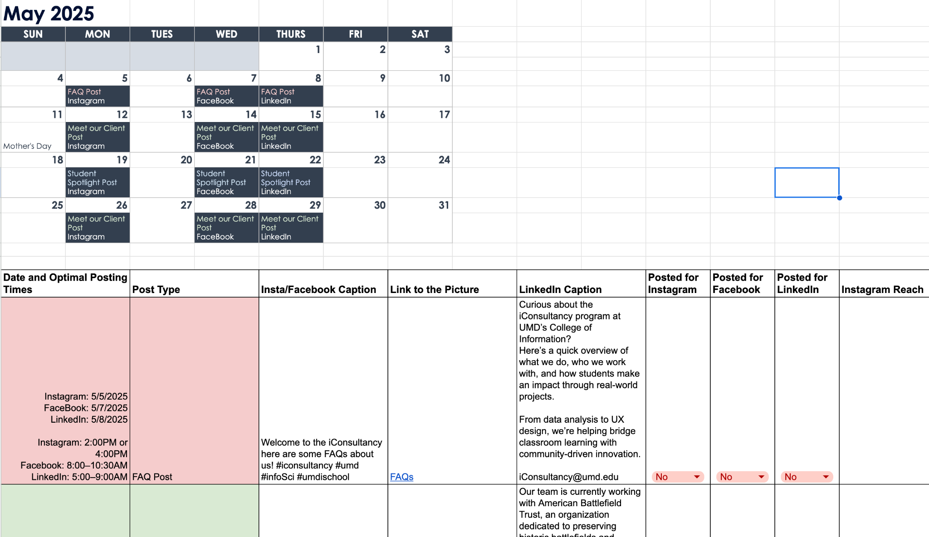

For the execution of this strategy, we created two deliverables. One is a two-month social media posting calendar with a detailed posting schedule with specific dates, platforms, content focus, and post type. The calendar provides post frequency recommendations and caption templates to maintain consistency in tone and messaging. It is easy to use and navigate, making it convenient to plan and schedule. The second deliverable is a reusable canva post template set. These templates are aesthetically pleasing, customizable, and organized by post category to support different types of content for different platforms and audiences. Post categories include FAQ posts, student spotlights, and client posts. These deliverables create a good foundation for creating and maintaining a strong social media presence for iConsultancy.

**FAQs about iConsultancy**

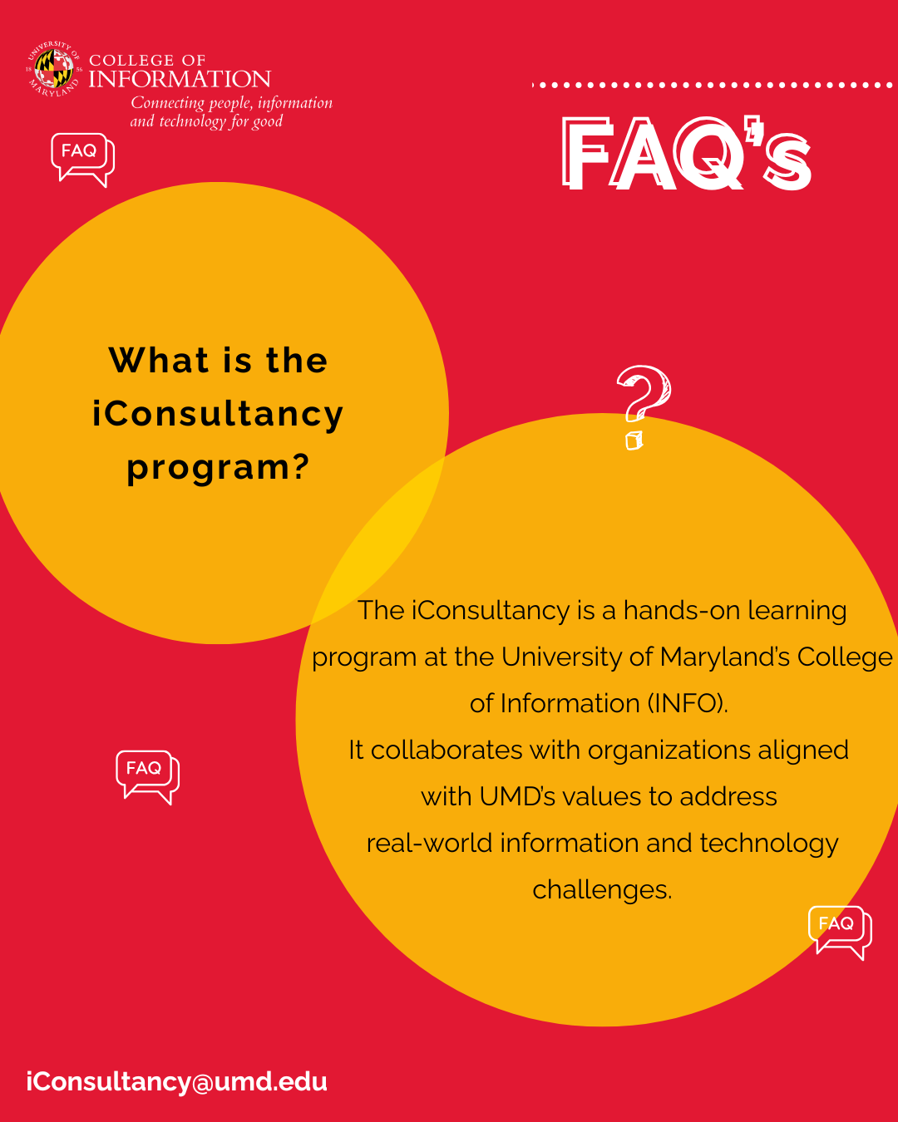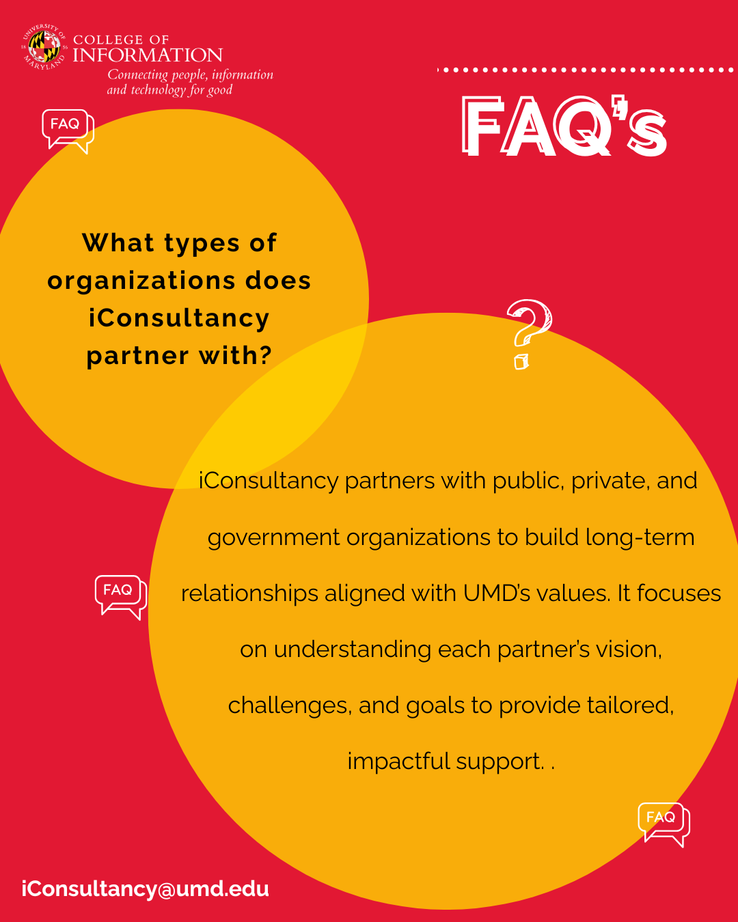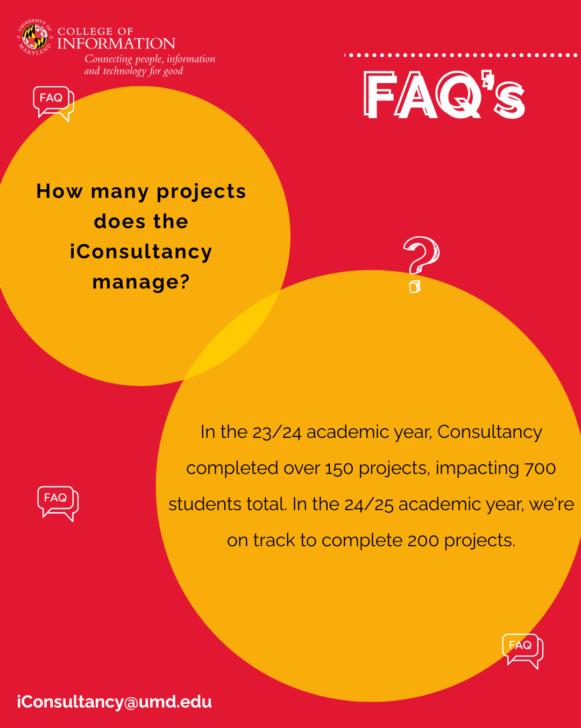

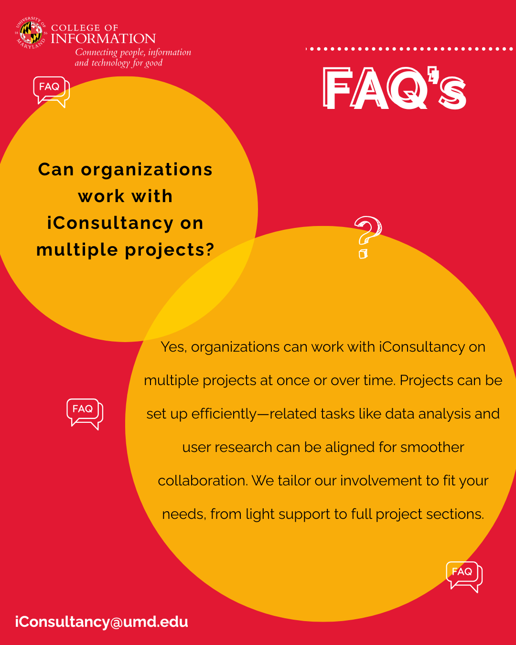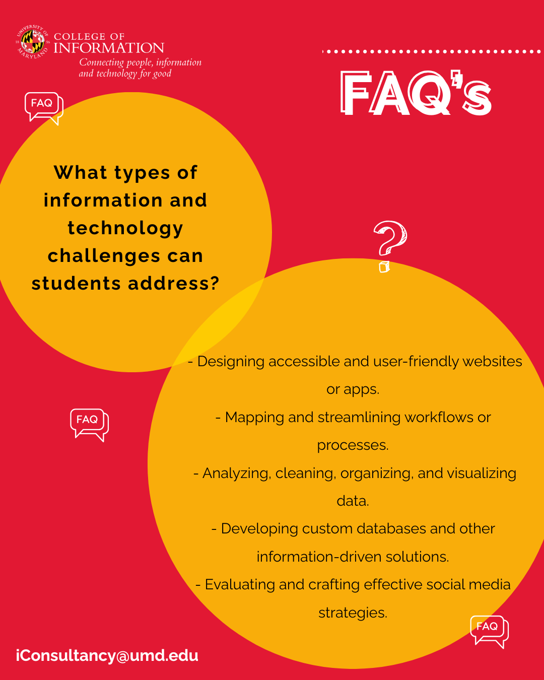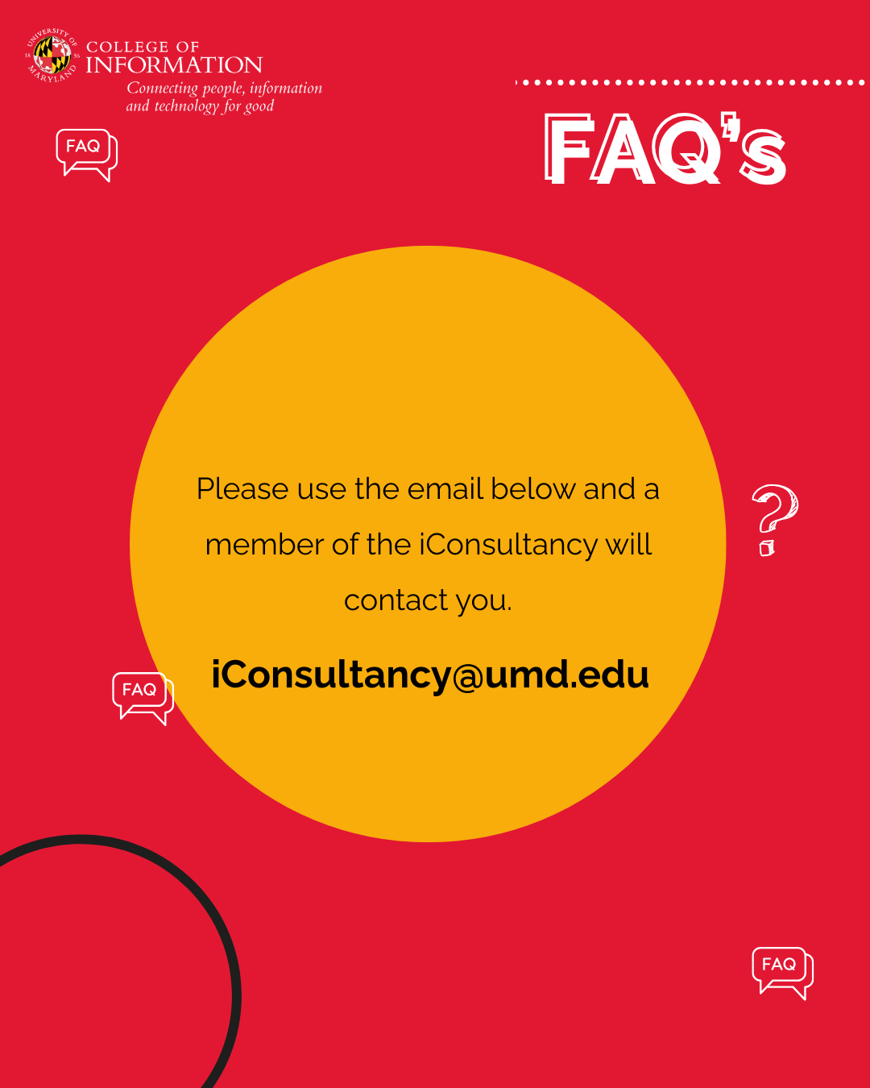

Frequently asked questions are all about what the iConsultancy program is and does. It gives clear answers to common questions people might have about the program, such as “What is the iConsultancy program?” and “What types of organizations does iConsultancy partner with?”, making it easier for organizations to take the next step. Additionally, a well-crafted FAQ section can be an invaluable resource for potential partners and internal team members. By proactively addressing common inquiries, the iConsultancy program can streamline communication and reduce the administrative burden on staff. This allows the team to focus on more strategic initiatives and provide enhanced support to partner organizations. In addition to its practical benefits, an FAQ section can contribute to the overall brand image of the iConsultancy program.

Stakeholders are more likely to be actively involved with a program if they know its core missions, who it helps, and how they can do their part. This is especially important for first-time partners who might not know what to expect from a university program. By presenting information clearly, concisely, and professionally, the program can reinforce its commitment to quality and transparency. This can help build a positive reputation and foster long-term relationships with stakeholders.

**Meet Our Clients**

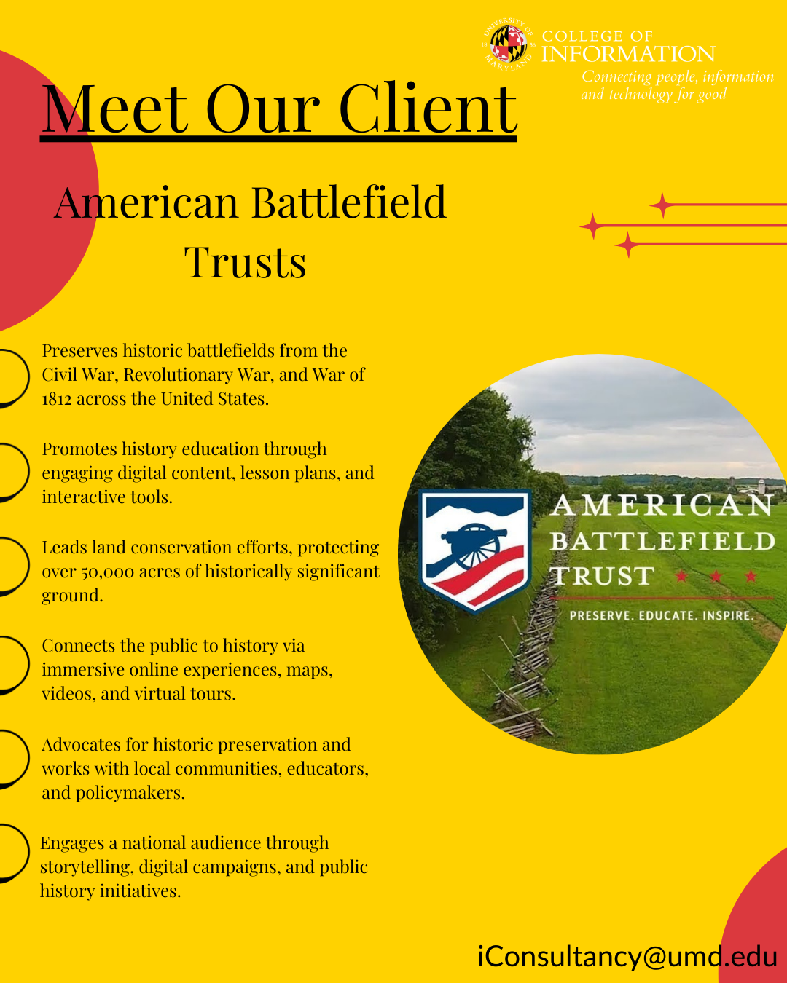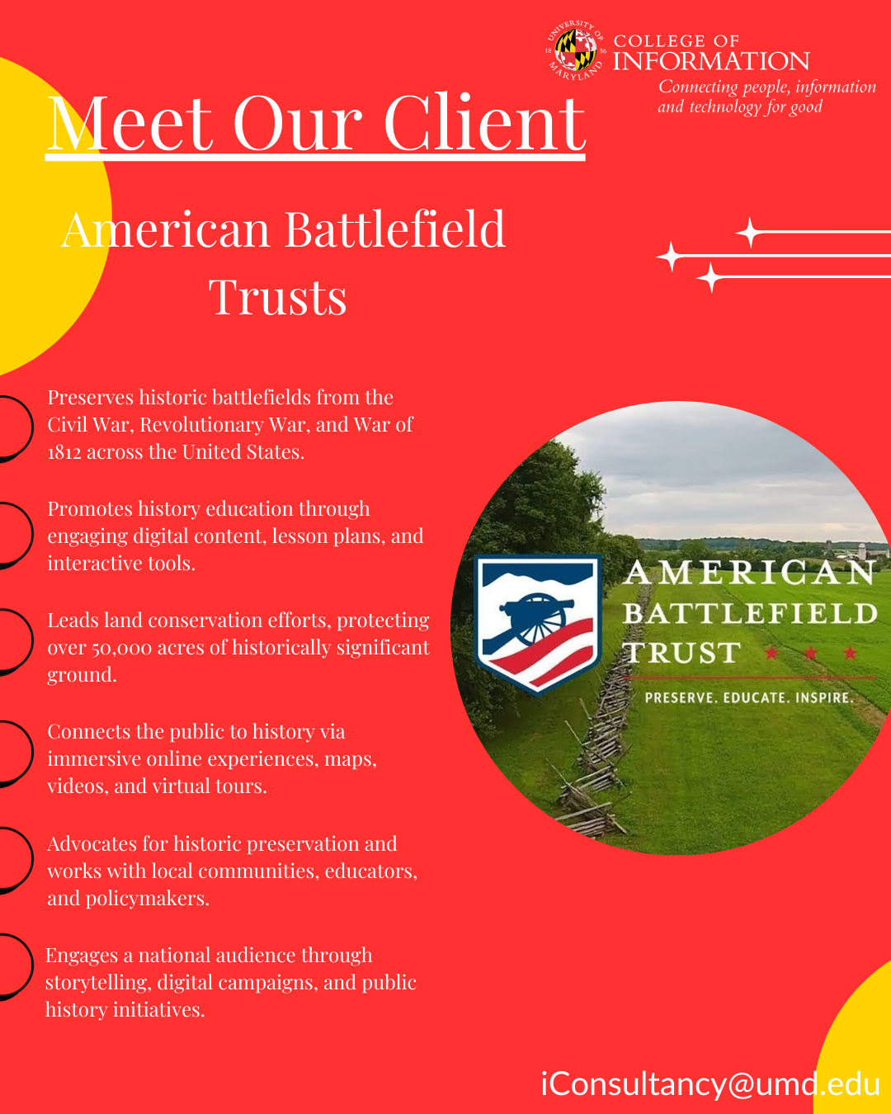

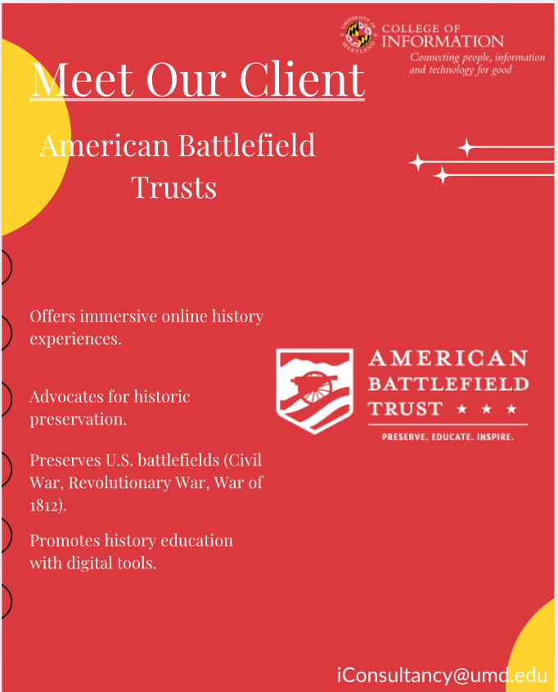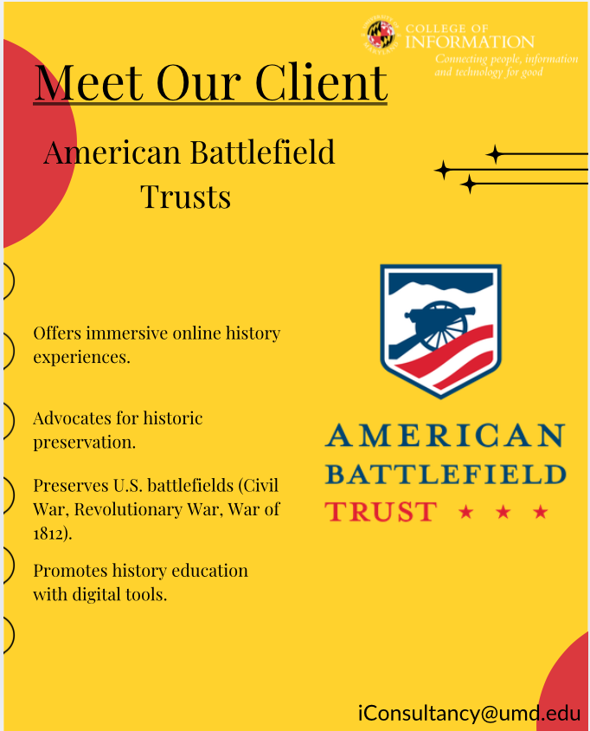

The purpose of a “Meet Our Client” post is to fulfill multiple functions. Not only does it bring the client’s work to the forefront, but it also highlights the iConsultancy as a cooperative and productive organization. These posts depict the real-world worth of student-led projects, build credibility for the iConsultancy, and celebrate the partnerships that are part of it. Publicly showcasing clients adds visibility to their mission, emphasizing the diversity and scope of iConsultancy’s goals and partnerships. From a social media perspective, these kinds of posts are enlightening yet promote engagement through storytelling to make shareable content that develops awareness and grows the brand.

These templates were designed using Canva. They feature neat fonts and a good structure made to be easily edited for each client’s mission and impact. We also used the UMD brand colors, which connect the posts to the broader identity of the iSchool. This keeps all communications and templates consistent and compliant with UMD’s branding guidelines.

**Current Clients**

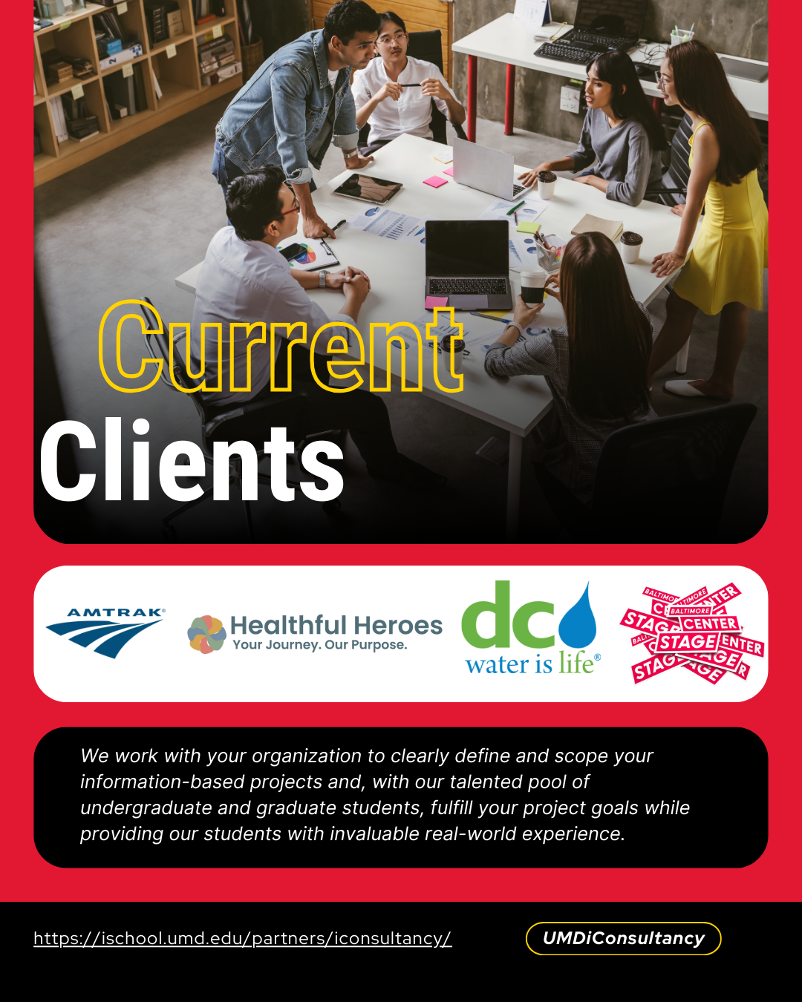

Showcasing current clients through a dedicated post helps reinforce iConsultancy’s credibility and track record of successful partnerships. By featuring well-recognized organizations like Amtrak and DC Water, this content functions as powerful social proof, demonstrating that respected institutions trust iConsultancy to deliver real-world solutions.

This type of post:

* Establishes legitimacy for prospective clients who may be unfamiliar with the program
* Demonstrates the diversity and scale of projects students have contributed to
* Encourages engagement from potential partners who identify with the featured clients’ industries or missions
* Promotes transparency and pride, both internally (students, faculty) and externally (stakeholders, partners)

Additionally, this post supports broader branding goals by visually aligning with UMD’s identity and directing viewers to learn more through the iConsultancy website. It also acts as a conversation starter on social media, encouraging shares, comments, and questions from potential clients.

**Student Spotlight**

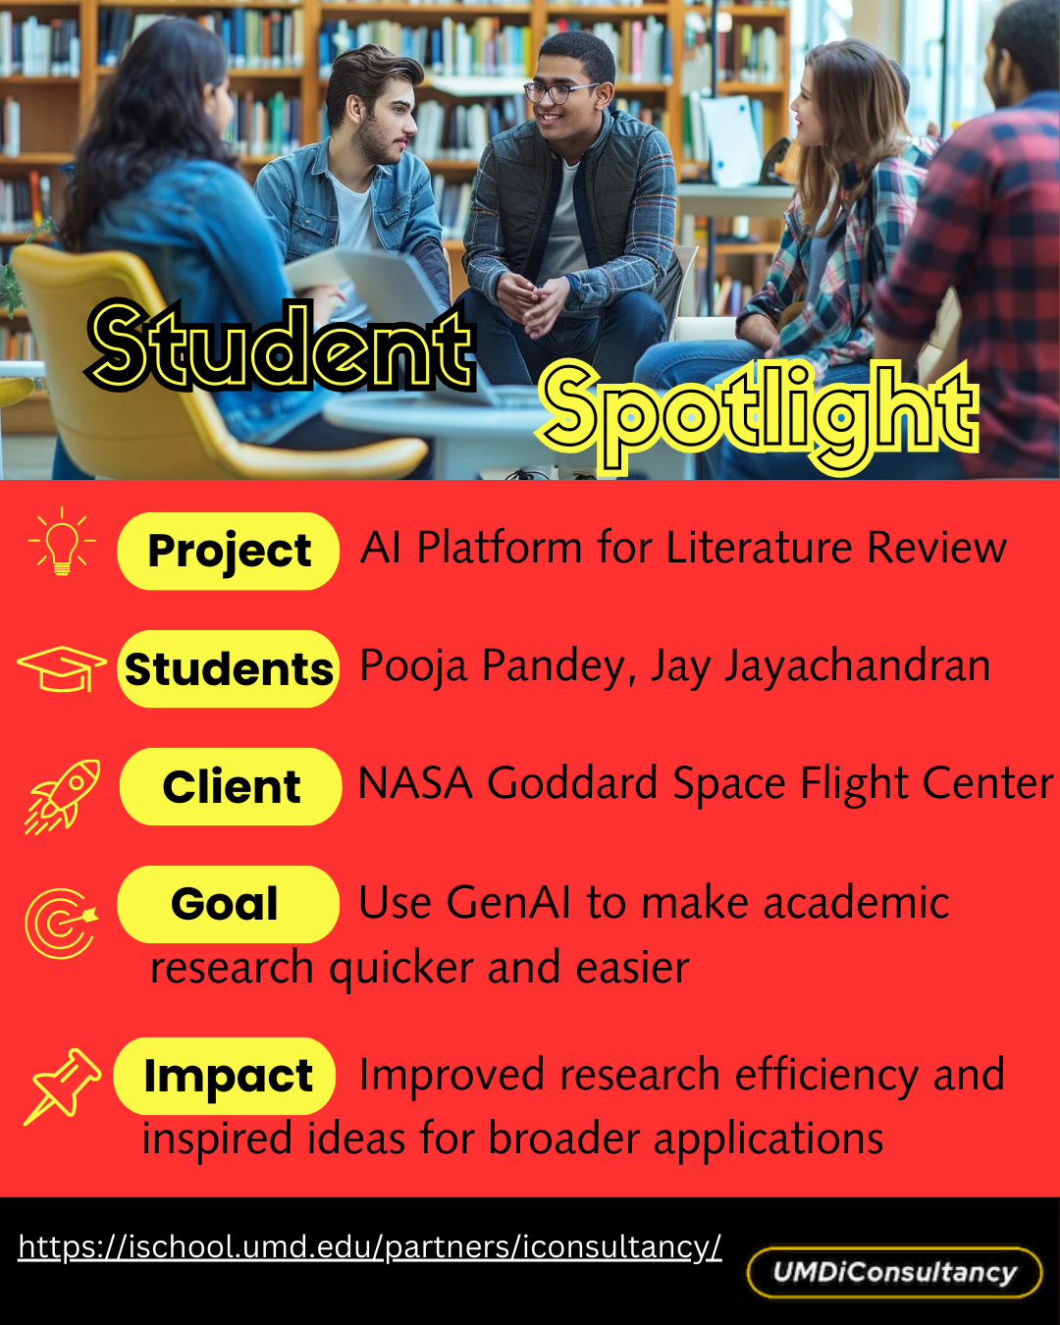

Our team also created a Student Spotlight template post to help iConsultancy showcase student contributions and project outcomes. Our client emphasized that highlighting student work was important for showing the program's value and recognizing the real-world skills students apply in their projects. The post was designed in Canva with a clean, structured layout that combines engaging visuals, icons, and clearly labeled sections. Each template part—Project, Students, Client, Goal, and Impact—is marked with a bold heading and corresponding icon to improve clarity and visual appeal. The content is concise and informative, highlighting the real-world applications of student work and the value provided to clients. The design is fully reusable, allowing our client to easily update the template with new students, projects, and impacts. This template supports the program’s goal of communicating its impact while maintaining a consistent and professional presence across platforms.

**Client testimonials**

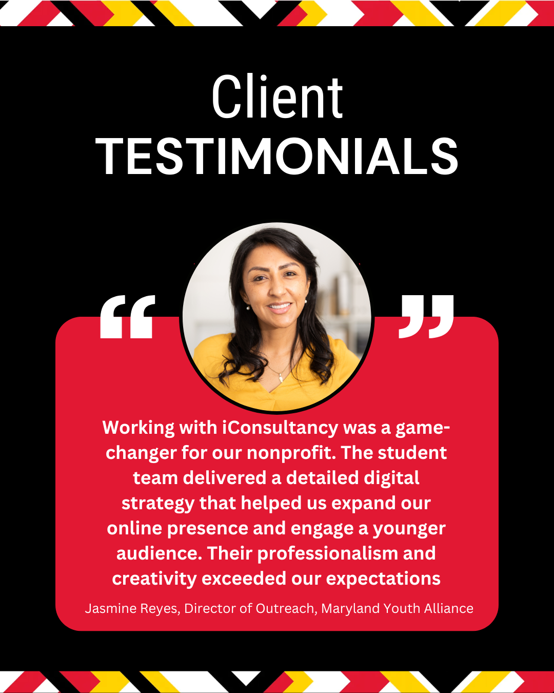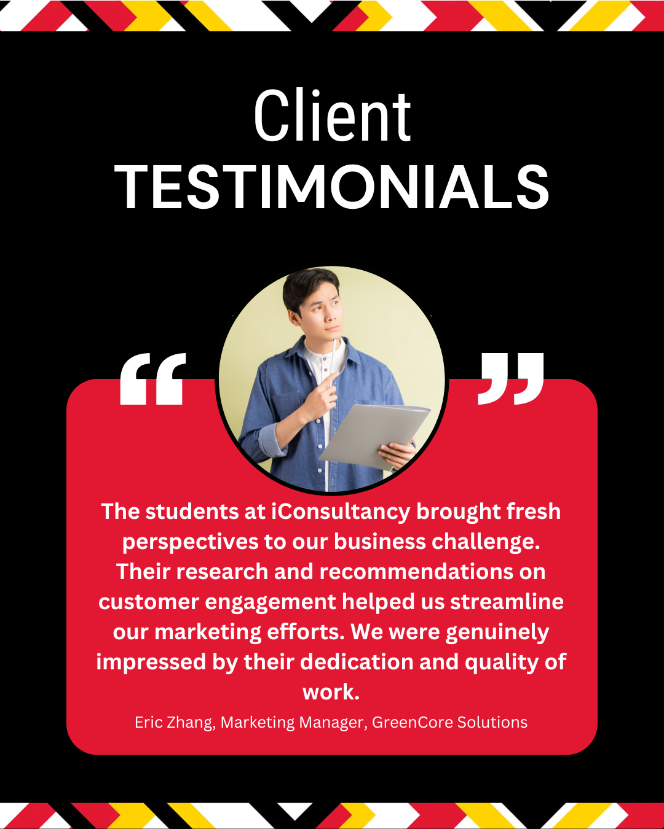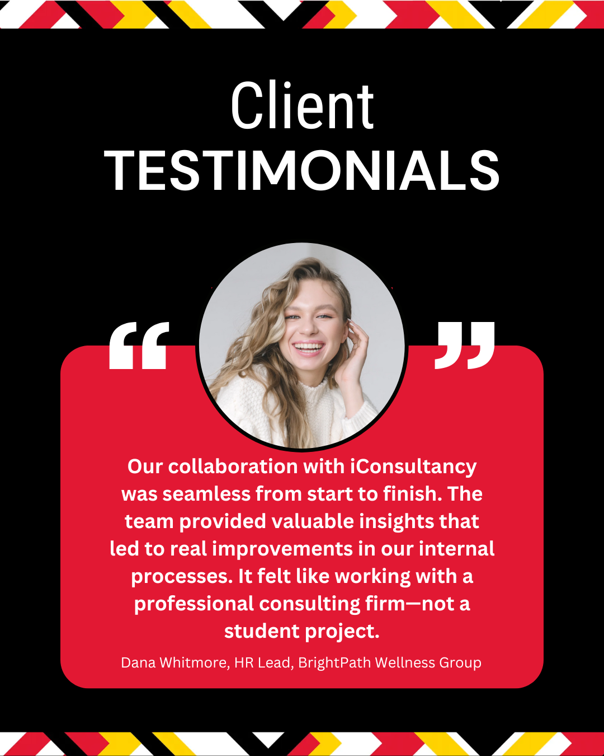

Client testimonials are a powerful form of social proof, enhancing credibility and building trust among potential clients. By highlighting the positive experiences of past partners or customers, testimonials offer third-party validation that is often more persuasive than direct marketing. This credibility can influence decision-making, especially in competitive environments where prospective clients seek reliability and authenticity.

In addition to boosting trust, testimonials help differentiate an organization by showcasing the unique value it provides through real-world impact. They also enhance a brand’s online presence, improving conversion rates on websites and social media platforms and contributing to a stronger overall reputation.

Our client testimonials highlight the client's work and relationship with the iConsultancy. We followed the Maryland brand by using Maryland colors and adding the fearlessly forward border while making these. While the content itself is examples, it is easily changeable within Canvas.

**Posting Strategy Overview**

We created a posting strategy designed to maximize engagement and brand presence on three primary platforms: LinkedIn, Instagram, and Facebook. We suggested a posting frequency of three times a week to maintain consistency and stay up to date without overloading the audience with too much content. To actively engage our target audience, we suggested employing different features such as polls, question boxes, and call-to-action captions that allow for more likes, comments, and shares. All these platforms have to follow their own tone and styling rules. LinkedIn posts should be professional in tone, Instagram should be more concise and visually focused, and Facebook can follow a noninformal style of writing. This platform-specific approach keeps things engaging, timely, and aligns with audience expectations.

**How they Support Client Needs**

These deliverables ensure that iConsultancy can establish and maintain a consistent and professional online presence without requiring significant time or design expertise. With a fully developed content calendar and pre-made post templates and captions, the client can focus on executing the strategy rather than building it from scratch. The strategy is designed to attract potential clients by showcasing successful projects and partnerships. It also engages current and prospective students by highlighting their contributions and the real-world impact of their work. It also helps build a cohesive and polished brand identity across platforms, reinforcing the program’s credibility and visibility within the academic and professional communities.

**Recommendations**

To build on the work completed during this project, our team recommends multiple short and long-term actions to support the successful launch and ongoing development of iConsultancy’s social media presence.

In the short term, the client should begin by creating official accounts on LinkedIn, Facebook, and Instagram and linking these accounts to the iConsultancy email. Once these are set up, the content calendar developed during this project can be used to begin posting regularly, with implementation ideally starting in May to align with the prepared schedule.

We also met with Craig Taylor, the iSchool's Communications Manager. He explained how the iSchool decides what to post and how his team plans out what to post each week. Craig mentioned many different tools that he used to help do automatic posting and planning for each platform at the beginning of the week. So, meeting with him and his team again would be a great way to begin when the accounts are made and the images and captions are ready to post.

Another group we worked with was the website design team, and we discussed adding our socials to the website directly. This way, the best or most informational post can be right on the screen when clients are searching for more information on the website.

In the long term, it will be important to review engagement analytics monthly to evaluate what types of content perform best. The client can adjust post formats, timing, and tone based on that information. Additionally, the client should expand the range of content to include alum success stories, semester recaps, and other features that continue to highlight the program's value to students and potential future clients.

**Appendices**

* Jira timeline screenshot

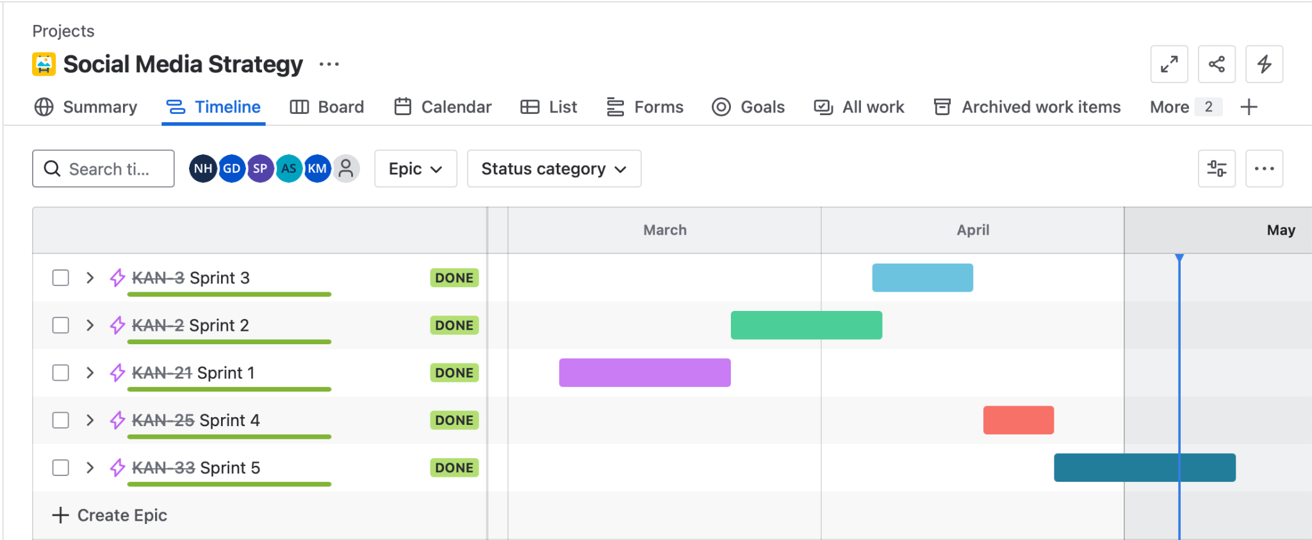

* Current clients link: [Current Clients](https://www.canva.com/design/DAGjmlsOZlw/lDe49xZlD4BNg4cZyTm9ZQ/edit?utm_content=DAGjmlsOZlw&utm_campaign=designshare&utm_medium=link2&utm_source=sharebutton)
* Meet our client (2 options) links:
  + Instagram:

[Meet our Client](https://www.canva.com/design/DAGmrxpspfg/25JkPKQ_q2N_Bz5Rm5m3oQ/edit?utm_content=DAGmrxpspfg&utm_campaign=designshare&utm_medium=link2&utm_source=sharebutton)

[Meet our Client](https://www.canva.com/design/DAGmr4a4w9g/OTlkyaRhIfXsvuQjQrxoKQ/edit?utm_content=DAGmr4a4w9g&utm_campaign=designshare&utm_medium=link2&utm_source=sharebutton)

* + FaceBook:

[Meet our Client](https://www.canva.com/design/DAGmxwz28-8/i0gu0ix1uaXklZ4jJ5qC-w/edit)

[Meet our Client](https://www.canva.com/design/DAGmx7mcm_w/6D2IGPbS1eIOYaHGZtycfA/edit)

* + LinkedIn:

[Meet our Client](https://www.canva.com/design/DAGmyJBsWyg/DcoskRvmxnvBzblR23AOeA/edit)

[Meet our Client](https://www.canva.com/design/DAGmyOjpn3I/CqOiR2OXB4hm1DIb0fCvPA/edit)

* FAQ Posts link:

[FAQ](https://drive.google.com/drive/folders/1ksu8CQZka55BkbnNcSVayp_sWW6Ugbfr?usp=share_link)

* Student Spotlight Post links:
  + Instagram: [Student Spotlight](https://www.canva.com/design/DAGmPojb4zU/6taxG_GSnS7_jEJ6PktjOA/edit)
  + FaceBook: [Student Spotlight](https://www.canva.com/design/DAGmPwt5PPg/TnEKxmTZWsknhGnsWtdltw/edit)
  + LinkedIn: [Student Spotlight](https://www.canva.com/design/DAGmP0KaCEM/PbJl0nzu9pb_yVNhtDxiAw/edit)
* Client testimonials link: [Client Testimonial](https://www.canva.com/design/DAGmrufeaU0/3G9J9xis6-Kxt7pfxWnvqA/edit?utm_content=DAGmrufeaU0&utm_campaign=designshare&utm_medium=link2&utm_source=sharebutton)

[Social Media Calendar](https://docs.google.com/spreadsheets/d/1lXWCsU1aPp-HXlpregyYVfLdWw-99akk9p3eRitEpYg/edit?usp=share_link)

[Meeting Minutes](https://docs.google.com/document/d/1cv8FtF6TzEUYmPlbHsvijQxonisXuuxbg8g5Y3EFgrg/edit?usp=share_link)

[Social Media Strategy](https://docs.google.com/presentation/d/1hi5X-r6QGGDgVyQ4LBt-9kQRBvCQo4aK0BZLbjpjUmE/edit?slide=id.gddd065997f_0_281#slide=id.gddd065997f_0_281)

**References**

Lang, Kirsti. “The Best Time to Post on Social Media in 2024: Every Major Platform.” *Buffer*, 24 Apr. 2025, [buffer.com/resources/best-time-to-post-social-media/](http://buffer.com/resources/best-time-to-post-social-media/).

Quesenberry, Keith. *Social Media Strategy: Marketing, Advertising, and Public Relations in the Consumer Revolution*. 3rd ed., Rowman & Littlefield, 2021, pp. 79–102, [books.google.com/books?hl=en&lr=&id=QWTyDwAAQBAJ&oi=fnd&pg=PR3&dq=info:jg4xCmO5WAkJ:scholar.google.com/&ots=BuqjUhHExM&sig=VdfVTq2yyrq8zcb0IIC9-EKJbbE#v=onepage&q&f=false](http://books.google.com/books?hl=en&lr=&id=QWTyDwAAQBAJ&oi=fnd&pg=PR3&dq=info:jg4xCmO5WAkJ:scholar.google.com/&ots=BuqjUhHExM&sig=VdfVTq2yyrq8zcb0IIC9-EKJbbE#v=onepage&q&f=false).

​​Hartshorne, David. “How to Turn Customer Feedback into Amazing Social Media Posts for Your Clients.” *Sendible*, 21 Feb. 2024, [www.sendible.com/insights/customer-feedback-on-social-media](http://www.sendible.com/insights/customer-feedback-on-social-media).